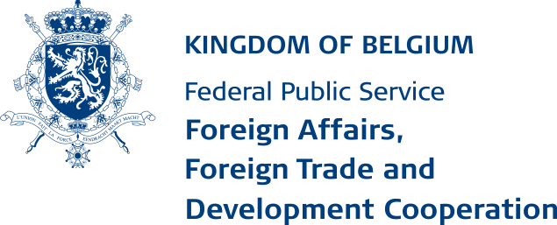
Archives Department
(ICT5.2)

Registration form and research declaration
- Identification and research data
Name :
First name :
Nationality :
Address :
Telephone/mobile phone number :
Research conducted within this framework :
To be specified : Institution/enterprise, faculty, promoters, research purpose (e.g. genealogical content), …
Full description of the research subject :
Will the data from these archival fonds possibly be subject to publication :
Which type of publication ? :
The archival fonds that will be consulted :
Confidentiality
By completing this form, you declare that you accept that your personal data may be stored and processed by the Archives Department of the FPS Foreign Affairs, Foreign Trade and Development Cooperation.
The personal data listed above will only be collected and processed by the Archives Department of the FPS Foreign Affairs, Foreign Trade and Development Cooperation (ICT 5.2) in order to provide a good service.
In accordance with the General Data Protection Regulation, you have the right to access, inform, modify and rectify your personal data. You are also entitled to object to the processing of your personal data for legitimate and justified reasons. If you wish to exercise your rights, please send your request to the following e-mail address: info.archives@diplobel.fed.be
-------------------------To be completed by the archivist-------------------------
- Decision made by the Archivist of the FPS Foreign Affairs or his representative
Permission to
!! This permission is granted on a strictly personal basis !!
Refusal (motivated) Name and signature of the Archivist of the FPS Foreign Affairs or his representative :
-------------------------To be completed in the reading room-------------------------
- Research declaration
Without prejudice to the legal provisions on the protection of natural persons with regard to the processing of personal data and on the free movement of such data (Regulation (EU) 2016/679 of the European Parliament and of the Council of the European Union of 27 April 2016), the undersigned hereby declares:
- that he/she will use the information from the above-mentioned archives only for the above-mentioned research purposes and that he/she will not publish anything, in any form whatsoever, that could harm the interests of the persons concerned, or those of other persons still alive.
- that he/she will not use or publish anything from these archives which may - harm the interests of the State and State Security; - harm the fundamental financial and economic interests of the State and other persons under public law; - harm the maintenance of public order and public security; - impede inspection, control or surveillance by or on behalf of a public authority; - impede the safeguarding of secrecy of information concerning trade, business and manufacturing, provided that such information has been communicated to the authorities in confidence.
- that he/she will observe the copyright law and respect the copyright of others.
- that he/she, in accordance with the legal provisions relating to the protection of privacy (see above), will not communicate to third parties personal information resulting from consultation of the said archives.

Done in , on
Applicant’s name and signature:

