  - Itinerary to the « CD » parking

- On the Ring of Brussels, follow the direction A201 Zaventem.
- Stay on your left and go straight ahead.
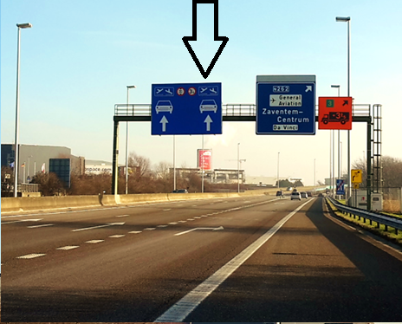

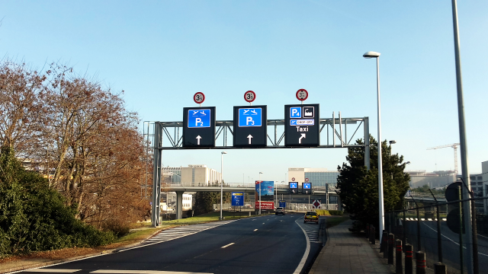
- Stay on your right and follow the sign 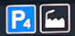

- Next, stay on the left lane and follow the sign
- You arrive at a roundabout. Follow the direction

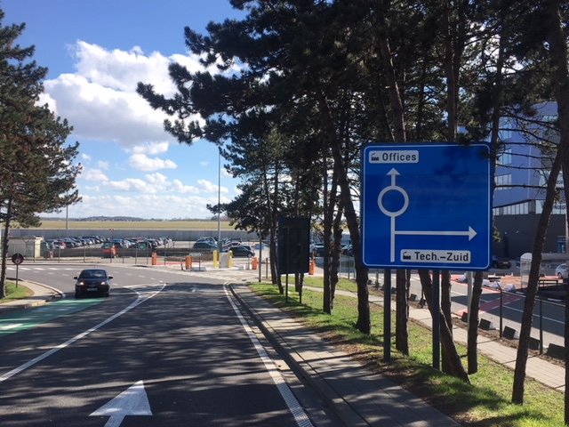

- Take the second exit and follow the sign “Passport”. The barriers will open automatically.

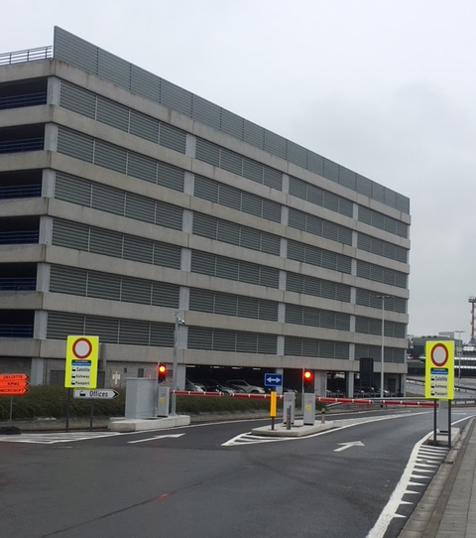

- Stay on the left lane and go straight ahead.
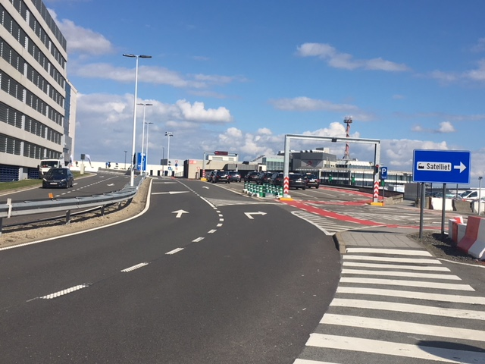
- At the roundabout, take the 2nd exit (on the right side of the grey building). The barrier will open automatically if your license plate is registered. If not, please show your parking card.
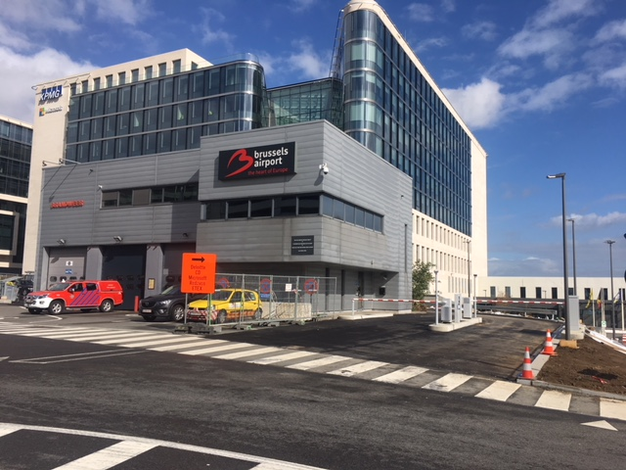
- Take the 3rd entry, indicated by the sign « CD ».
