  - Directions to the Protocol Building of Brussels Airport Company

- On the Brussels Ring, follow the signs for A201 Zaventem Luchthaven (Zaventem Airport).
- Stay on the main road A201 and keep to the right (over the viaduct).

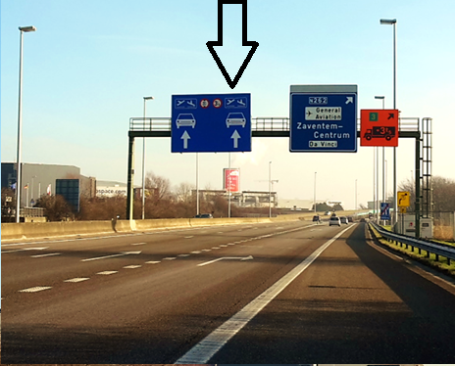

- After the viaduct, keep to the far right and follow the signs 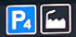
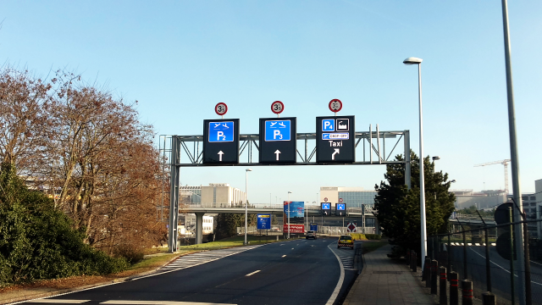

- You arrive at a roundabout.

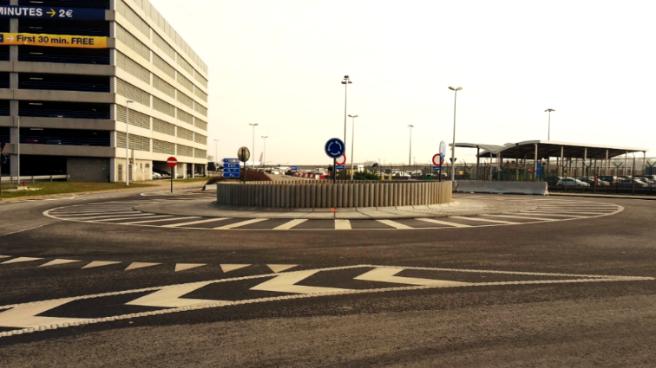

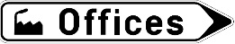
- Take the 2nd exit and follow the ‘offices’ sign
Visitors/Guests for the Protocol Building are permitted exceptions and may go past the prohibition sign.

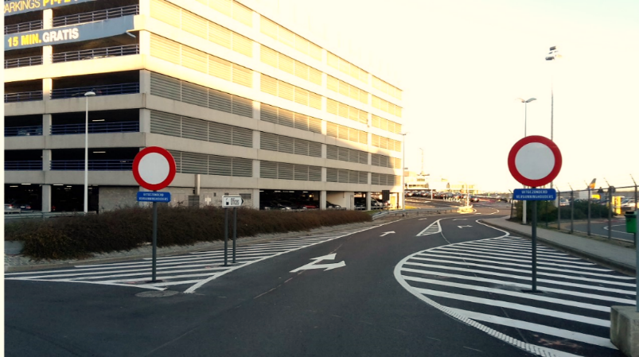

- Continue until you arrive at the second roundabout. Here, take the first exit (straight ahead)

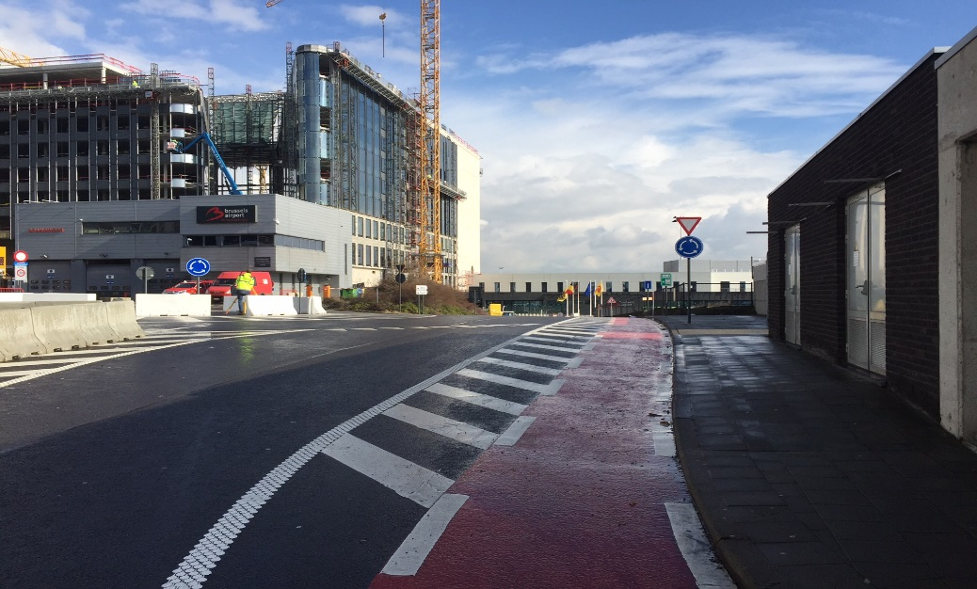

- Continue until you see the barrier at you right. Here you can identify yourself through the intercom

